**How to run the project**

Requisites:

**\*** Excel and Excel develop bar

**\*** Microsoft dot framework 4.0 or >

Execute the exe in location ( Vba_macro\Vba_macro\bin\Debug ) Vba_macro

The program is open insert number end line sheet excel.

Steps:

**1°** - Insert values in sheet excel

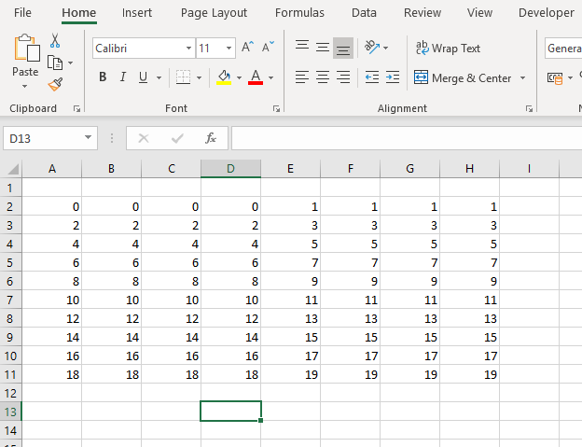

**2°** - Open vba macro exe and input total lines in sheet this example is 10

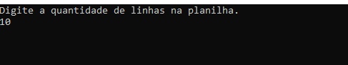

Copy all code generate

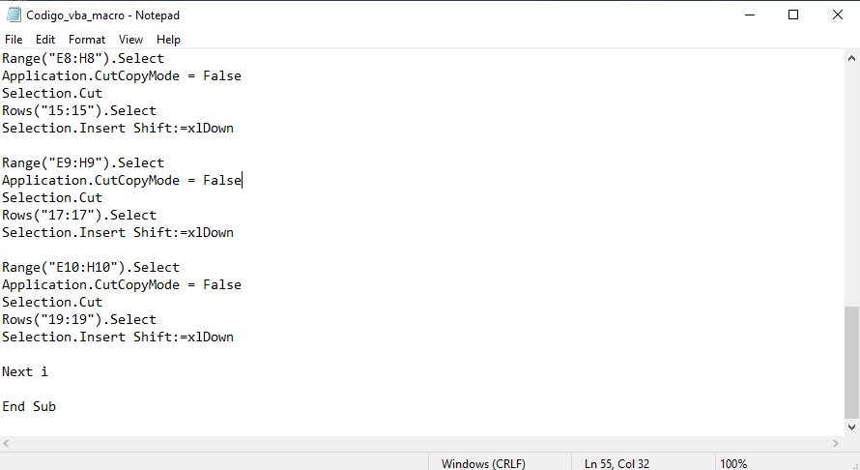

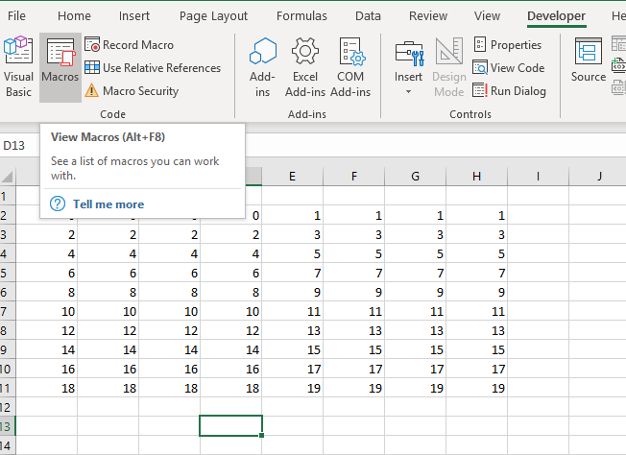

Paste code in Microsoft visual basic

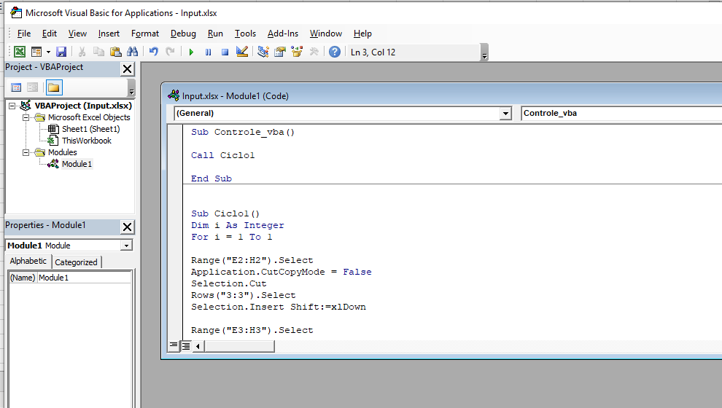

**3°** - Run code

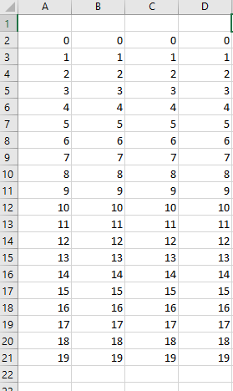

Result

**How to compile or debug the project**

Requisites:

**\***Visual studio 2018 or >

**\*** Excell and Excell develop

**\*** Microsoft dot framework 4.0 or >

**\***All archives of respository github vba macro

Example in job:

**1° -** Download this project.

**2° -** Open Vba_macro.sln